DELETE */*+ NOPARALLEL*/* FROM parallel_example;

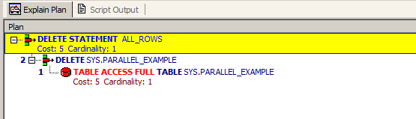

*-------------------PARALLEL DML----------------------------------*

ALTER SESSION FORCE PARALLEL DML;

INSERT INTO parallel_example SELECT * FROM times WHERE ROWNUM < 3000;

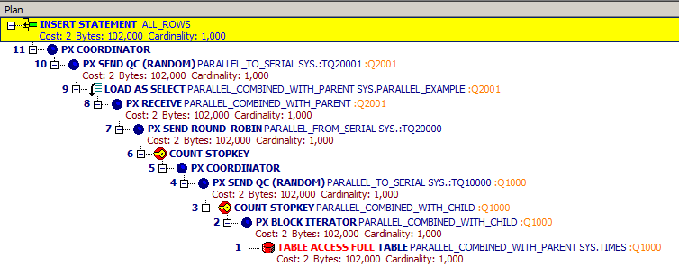

UPDATE parallel_example SET day_name = 'Weekend';

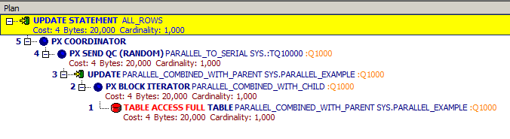

DELETE from parallel_example;

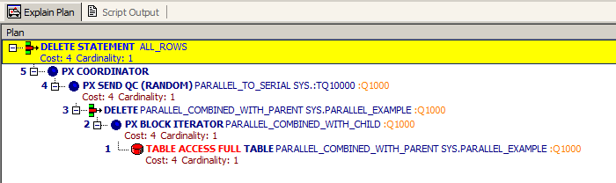

|  |  |  |  |
| --- | --- | --- | --- |
| **DML** | INSERT | UPDATE | DELETE |
| NONPARALLEL | 4 | 5 | 5 |
| PARALLEL | 2 | 4 | 4 |

## Task 03: CREATE Example of Parallel DDL

CREATE */*+ NOPARALLEL*/* TABLE parallel_example PARALLEL(DEGREE 4)

AS SELECT * FROM times WHERE ROWNUM < 3000;

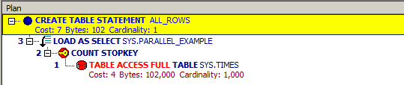

ALTER SESSION FORCE PARALLEL DDL;

CREATE TABLE parallel_example PARALLEL(DEGREE 4)

AS SELECT * FROM times WHERE ROWNUM < 3000;

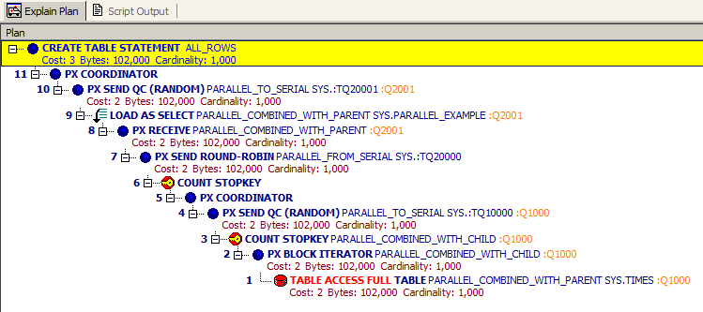

|  |  |
| --- | --- |
| **DDL** | CREATE |
| NONPARALLEL | 7 |
| PARALLEL | 3 |